**EXPNO 2: CREATE A VIRTUAL MACHINE WITH 1 VCPU, 2GB RAM AND 15GB**

**STORAGE DISK USING A TYPE 2 VIRTUALIZATION SOFTWARE**

**PROCEDURE:**

**STEP 1:**

**DOWLOAD VMWARE WORKSTATION AND INSTALLED AS TYPE 2**

**HYPERVISOR**

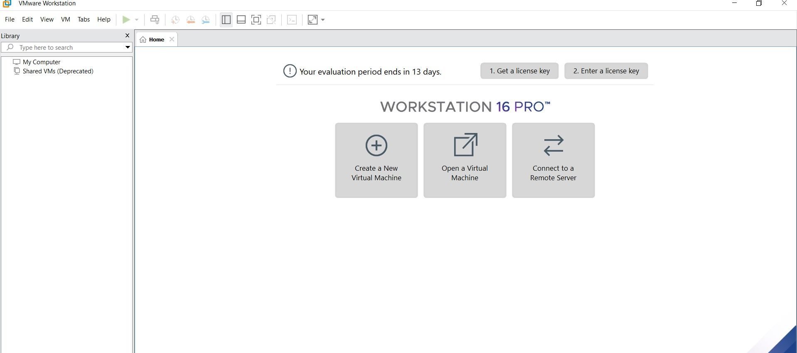

**STEP2: DOWLOAD UBUNTU OR TINY OS AS ISO IMAGE FILE**

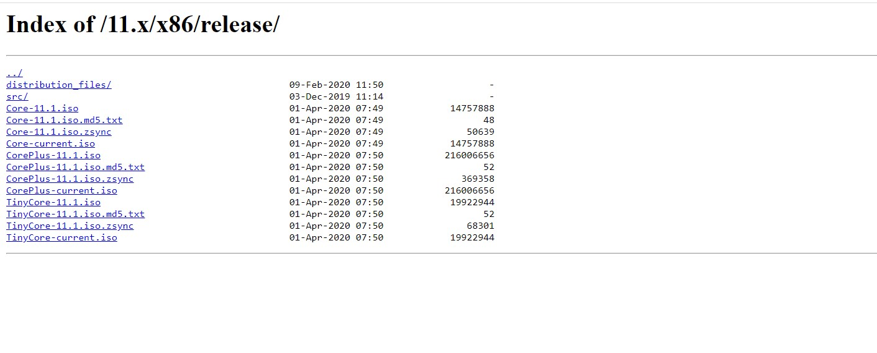

**STEP 3: IN VMWARE WORKSTATION->CREATE NEW VM**



**STEP 4: DO THE BASIC CONFIGURATION SETTINGS.**

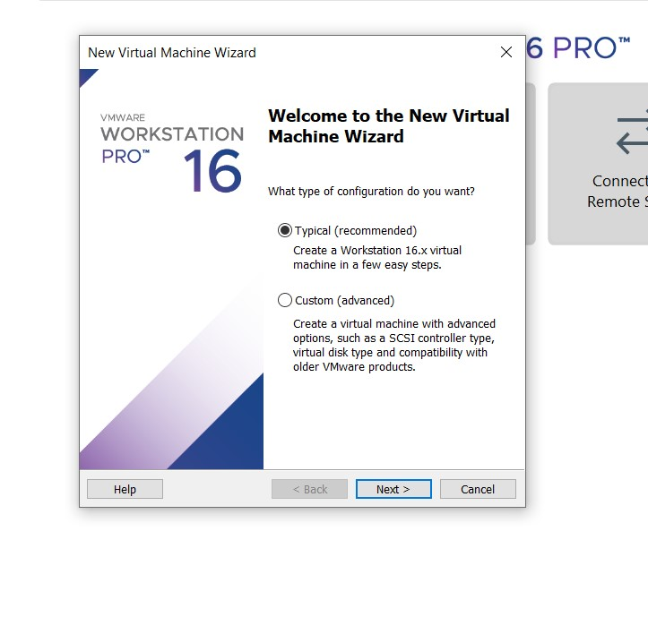

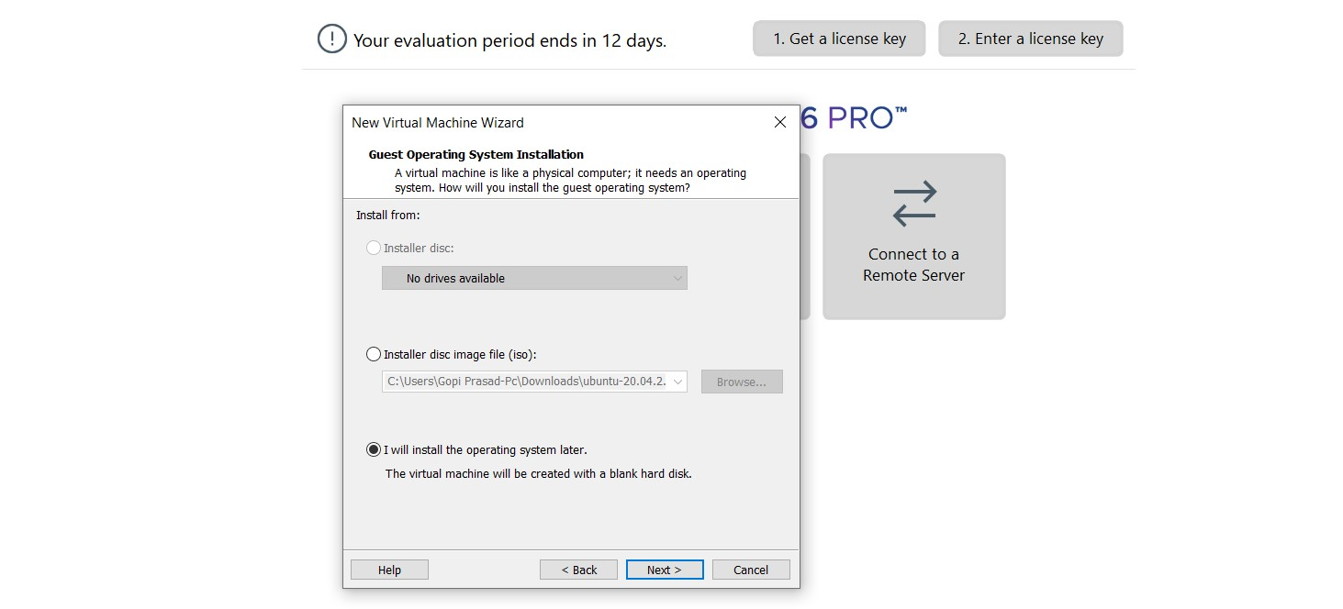

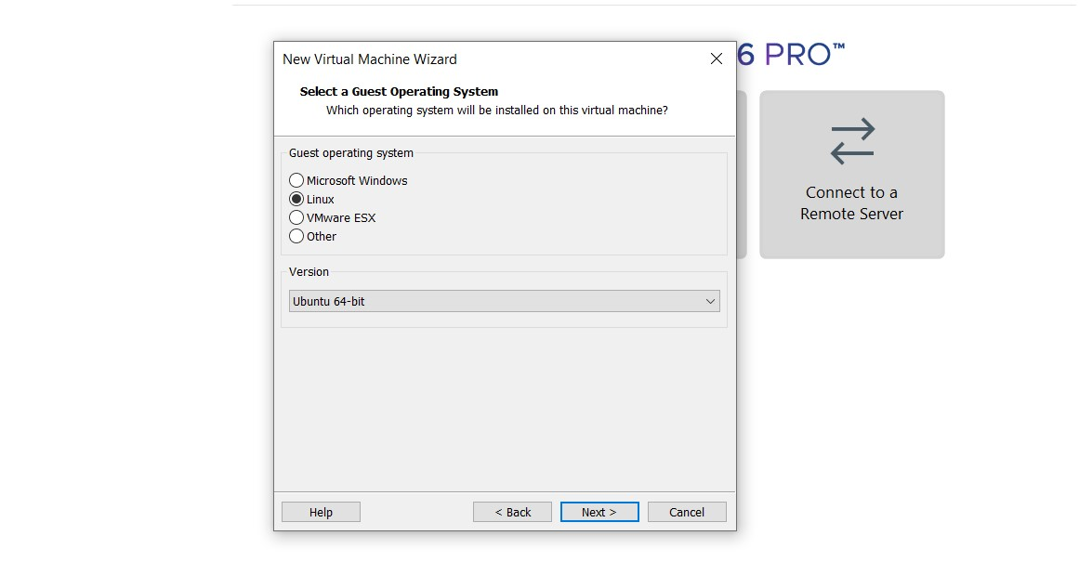

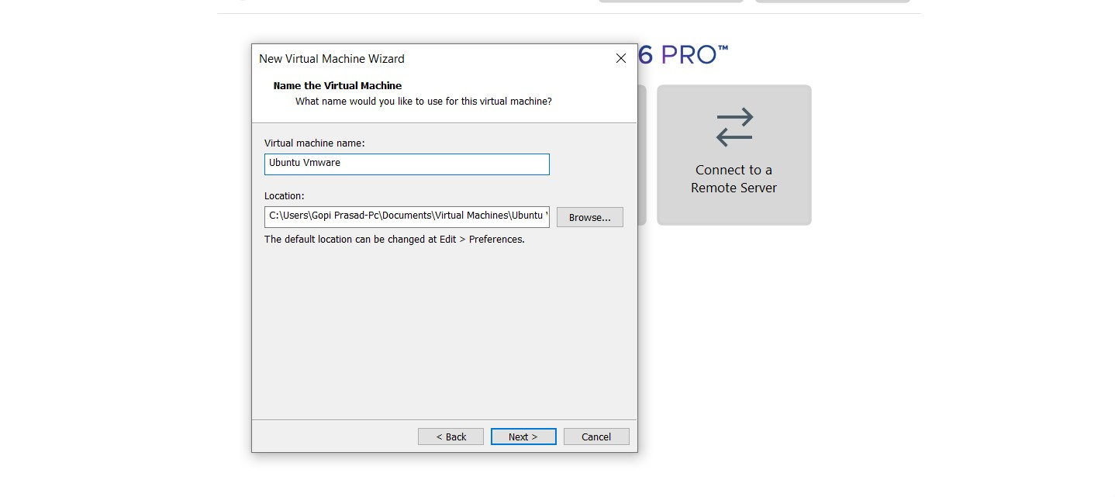

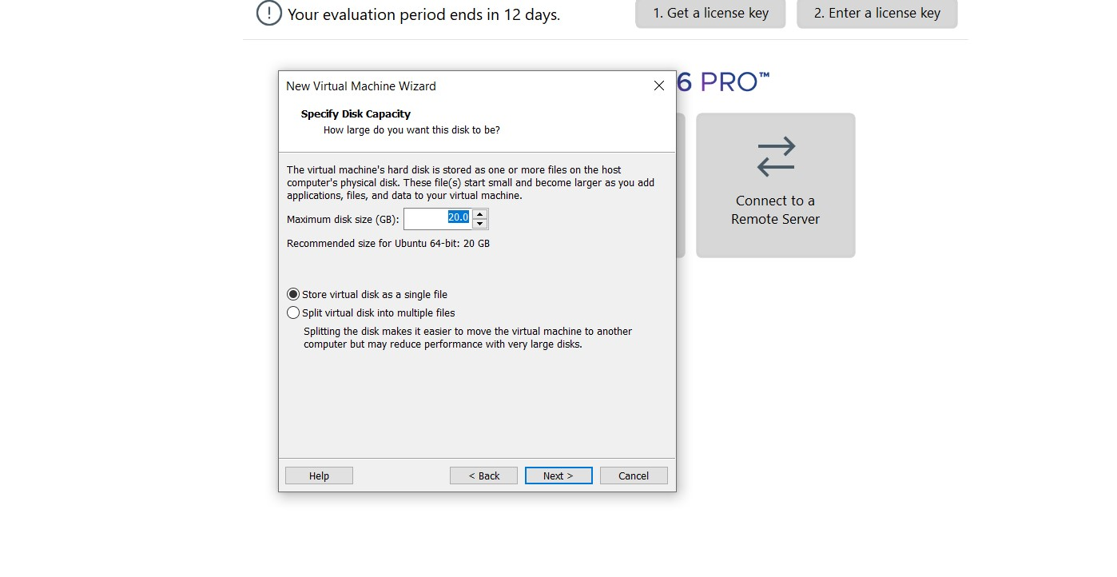



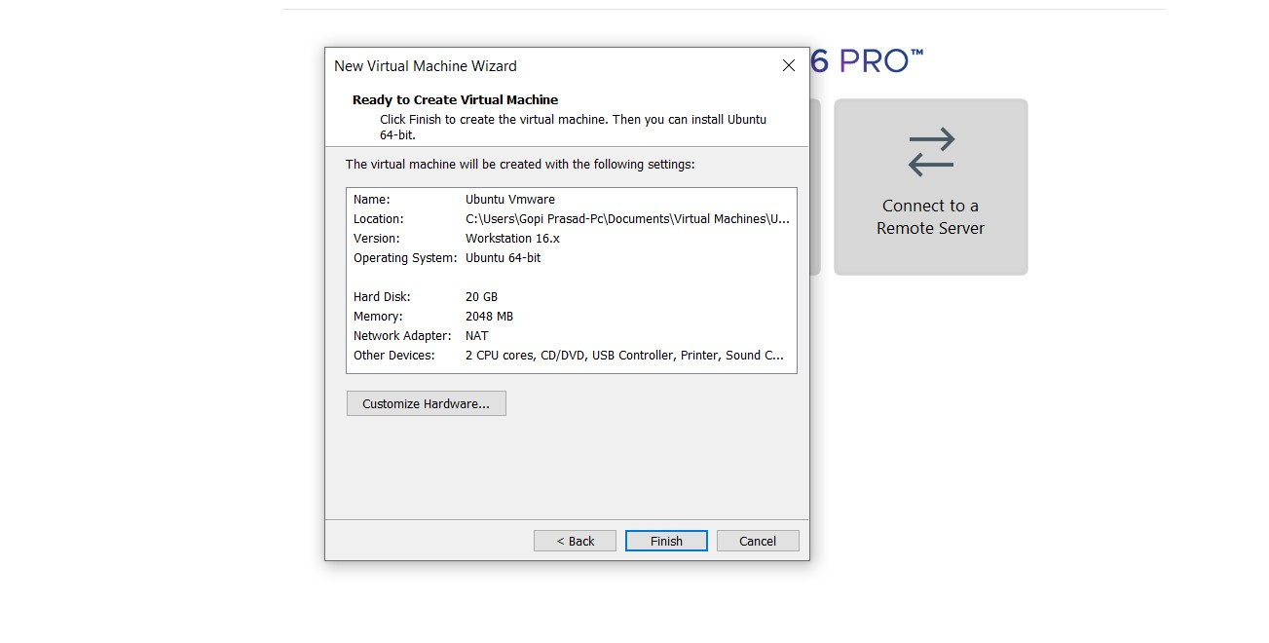

**STEP 4: CREATED TINYOS VIRTUAL MACHINE**

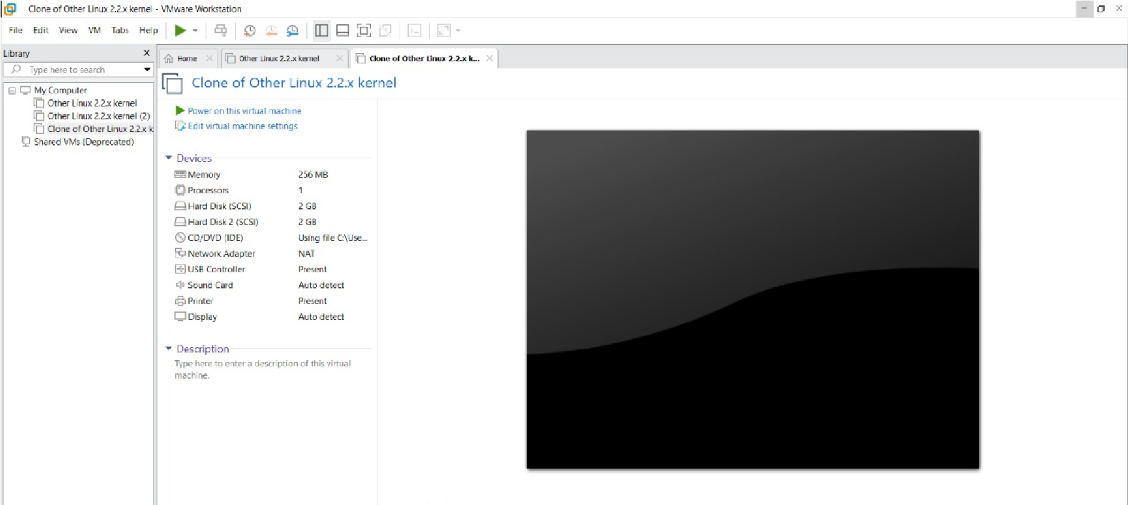

**STEP 5: LAUNCH THE VM**

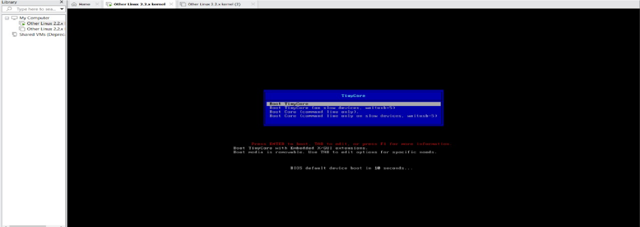

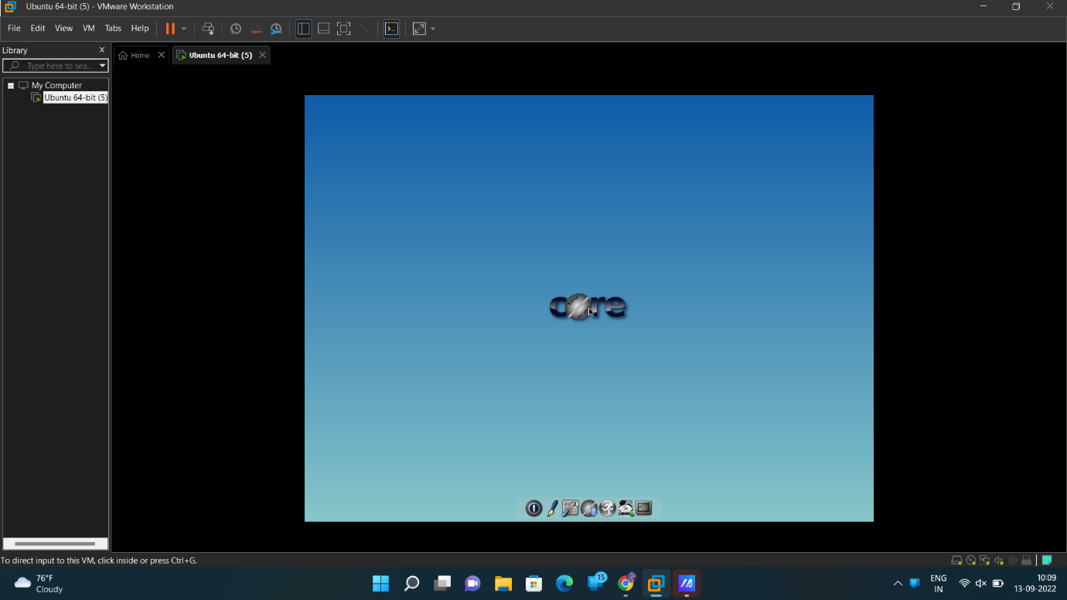**RESULT**